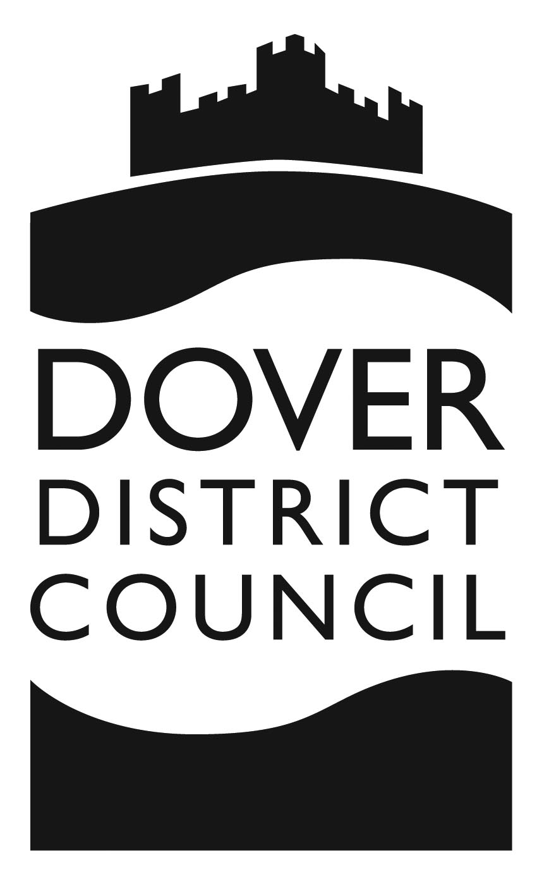

STAFF DISCLOSURE FORM

Private and Confidential

To be completed by all members of Staff

PREMISE DETAILS

Name:

Address:

STAFF DETAILS

Photograph: | Please affix photograph here
Name:
(To include any previous names you have had.)

D.O.B:

Address:
(Current address and if less than three years previous, a previous address.)

Capacity in which employed:

Criminal Conviction/s:
(Please list details.)

DECLARATION:

I declare that the information given on this form is true to the best
of my knowledge and that the photo supplied is of me (the person
named on this form).

(a) I declare that I have no criminal convictions
(b) My previous convictions have been listed on this form.

I agree to the premises detailed on this form or the Licensing Authority
of this premises to carry out any checks against the information given
on this form.

If it is found I have given a false statement on this form, it may result
in the instant dismissal under gross misconduct by the aforementioned Premises and or legal action being taken against myself by either the Premises or the Licensing Authority.

Signature:

Name (print):

Date:

